Solution to Problem: 1

A cellular service provider decides to use a digital TDMA scheme which can tolerate a signal to- interference ratio of 15 dB in the worst case. Find the optimal value of N for
(a) omnidirectional antennas, (b) 120° sectoring, and (c) 60° sectoring. Should sectoring be used? If so, which case (60° or 120°) should be used? (Assume a path loss exponent of n = 4 and consider trunking efficiency.)

Solution

(a)
Given:

Path loss exponent (n)=4
Tolerable signal to interference ratio, 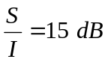

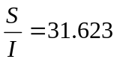

Assuming 6 interferers from the first tire of co-channel cells,

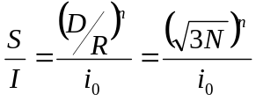

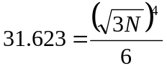

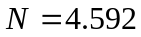

Since we have to choose higher possible value to satisfy the S/I requirement,

N=7

If we calculate S/I from N=7, we get 18.66 dB (Calculate!), which is better than the requirement.

(b)
120° Sectoring

Let us consider first that N=4, (i=2,j=0) .If we see the layout of the cells with N=4, it seems as below.
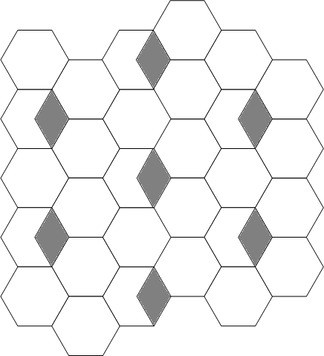

It is clear from the diagram that with 120° sectoring and N=4,there are 2 interferers in the first tier of co-channel cells.

Taking i₀=2 in the expression

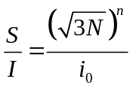
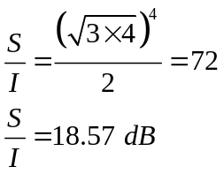

With 120° sectoring, the S/I obtained is better than required. So N=4 can be used.

We have to again check for N=3

Let us consider that N=3, (i=1,j=1) .If we see the layout of the cells with N=3, it seems as below.

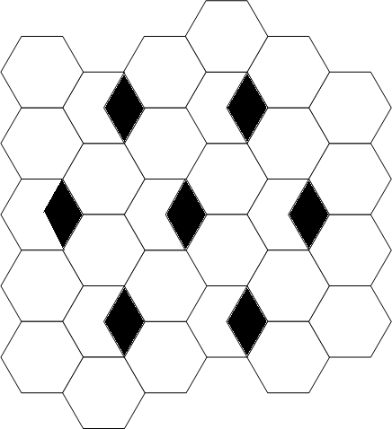

Taking i₀=3 in the expression

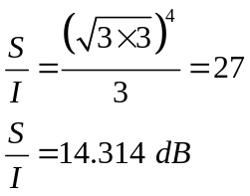

Since it is lower than the required value, N=3 cannot be used.

(b)

60° Sectoring

Let us consider first that N=4, (i=2,j=0) .If we see the layout of the cells with N=4, it seems as below.
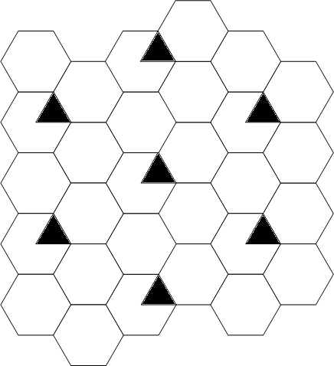

It is clear from the diagram that with 60° sectoring and N=4,there are 1 interferer in the first tier of co-channel cells.

Taking i₀=1 in the expression

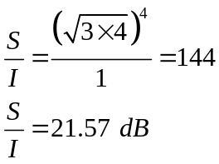

With 60° sectoring, the S/I obtained is better than required. So N=4 can be used.

We have to again check for N=3

Let us consider that N=3, (i=1,j=1) .If we see the layout of the cells with N=3, it seems as below.

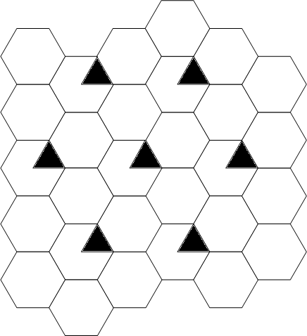

Taking i₀=2 in the expression

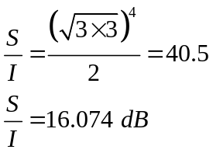

Since it is lower than the required value, N=3 can be used.

To satisfy the S/I requirement, optimum values of N are
N=7 for omnidirectional antenna
N=4 for 120° sectoring
N=3 for 60° sectoring

To check the overall performance, the trunking efficiency must be taken into account.

Assume

Traffic per user=0.04 Erl.
GOS=2%
Total number of traffic channels = 420

- Omnidirectional antenna (N=7)

No of channels per cell=420/7=60
With 2% blocking, Traffic supported per cell = 49.64 Erl

Total no of users supported per cell=(49.64/0.04)=1241

- 120 ° sectoring antenna (N=7)

No of channels per cell=420/7=60
No of channels per sector=60/3=20

With 2% blocking, Traffic supported by one sector = 13.18 Erl

With 2% blocking, Traffic supported per cell= 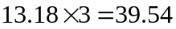 Erl

Total no of users supported per cell=(39.54/0.04)=988.5≈ 988
- 60° sectoring antenna (N=7)

No of channels per cell=420/7=60
No of channels per sector=60/6=10

With 2% blocking, Traffic supported by one sector = 5.048 Erl

With 2% blocking, Traffic supported per cell= 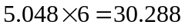 Erl

Total no of users supported per cell=(30.288/0.04)=757.2≈ 757

Reduction in trunking efficiency using 120° sectoring =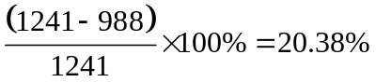

Reduction in trunking efficiency using 60° sectoring =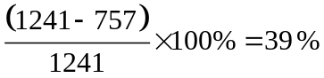

It is clear from above result that if sectoring does not result the lower value of cluster size, then it is harmful as sectoring decreases the trunking efficiency. The advantage is due to reduction in required value of N, which is seen below.

- 120 ° sectoring antenna (N=4)

No of channels per cell=420/4=105
No of channels per sector=105/3=35

With 2% blocking, Traffic supported by one sector = 26.44 Erl
Traffic supported by one cell = 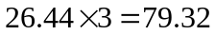

Total no of users supported per cell=(79.32/0.04)=1983

- 60 ° sectoring antenna (N=3)

No of channels per cell=420/3=140
No of channels per sector=140/6=23.33≈23

With 2% blocking, Traffic supported by one sector = 15.76 Erl
Traffic supported by one cell = 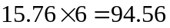

Total no of users supported per cell=(94.56/0.04)=2364

For the given number of channels in the system, 60° sectoring with N=3 gives the largest capacity.

